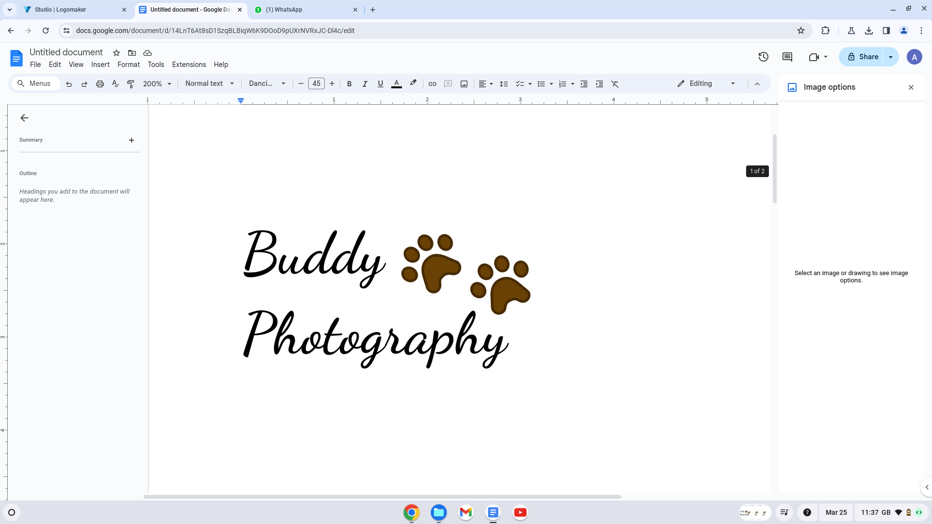

**PRIOR TO THE PHOTOSHOOT**

Before your furry friend has a photoshoot, we need to make sure we can get the most out of our session! So there are a few things below that we’d highly recommend you can do to get maximum potential out of your pet (and yourself)!

* Have your pet freshly groomed beforehand.
* If you’re having a studio photoshoot, ensure your pet is relaxed. Your dog may need a big walk before the session to burn off excess energy if you have an excitable pet.
* If you have a favourite collar, bandana, bow, or any other accessory your pet enjoys wearing then make sure you bring it along!
* Consider whether you want to be in the shots or not and dress accordingly. You don’t want to miss an opportunity because you don’t feel you are looking your best.

We’d like to make sure we can do the best we can to create the pictures of your dreams, so it is extremely helpful if you could let us know whether you’d like some specific requirements, this way we can get the studio and equipment setup accordingly ahead of time and so that the photos can be edited accordingly.

Below there are a few things to consider, so please let us know if you’d like us to incorporate any specific types of photography.

|  | Yes please! | No thank you! | Maybe! |
| --- | --- | --- | --- |
| Looking at the camera |  |  |  |
| Looking natural |  |  |  |
| Black & White |  |  |  |
| Action shots |  |  |  |
| Lying down |  |  |  |
| Special tricks |  |  |  |
| Bubbles |  |  |  |
| Clothes (studio only) |  |  |  |
| Hats (studio only) |  |  |  |
| Props (studio only) |  |  |  |
| Owner & Pet |  |  |  |