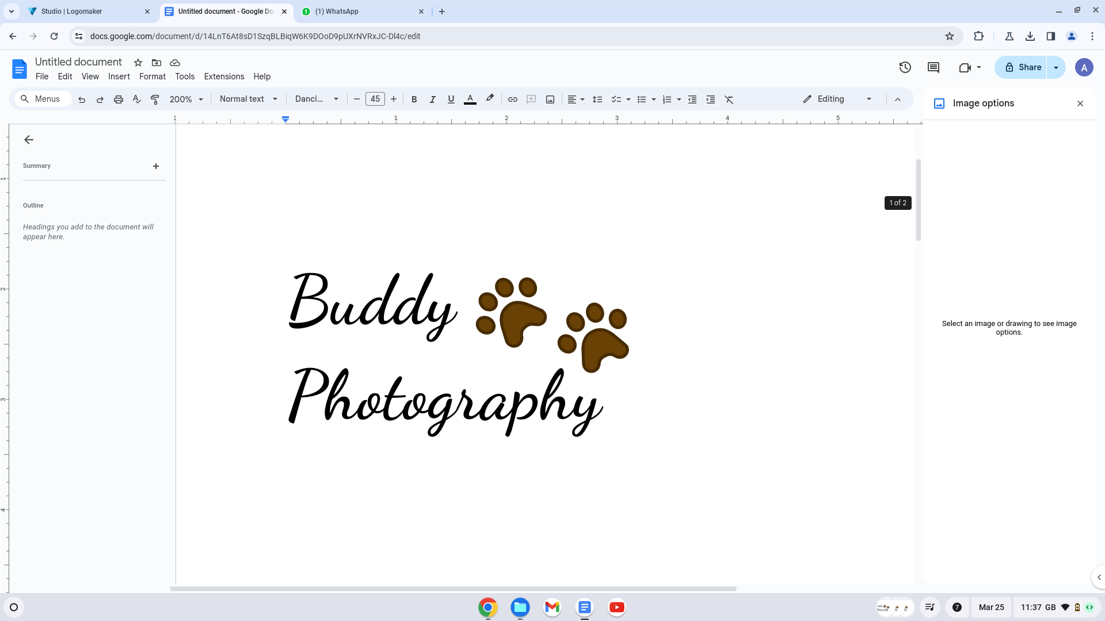

**PHOTO CONSENT FORM**

I, _____________________________ grant permission to Kirsty Ogborne (the photographer for Buddy Photography) for the use of the photograph(s) or electronic media images as identified below in any presentation of any and all kind whatsoever. I understand that I may revoke this authorization at any time by notifying Kirsty Ogborne (the photographer for Buddy Photography) in writing. The revocation will not affect any actions taken before the receipt of this written notification. Images will be stored in a secure location and only authorized staff will have access to them. They will be kept as long as they are relevant and after that time destroyed or archived.

Name…………………………………………………………….

Address…………………………………………………………….…………………………………………………………………………………………………………….…………………………………………………………….……………………………………………………………………………………………Postcode………………………………

Phone…………………………………………………………….

Email …………………………………………………………….

Signature ……………………………………………………………. Date ………./………./……….

Please email this back to [info@buddyphotography.co.uk](mailto:info@buddyphotography.co.uk) prior to the photoshoot or bring this with you to the photoshoot.